**EXPERIMENT NO. - 4**

**Object**: Determination of Izod/ charpy Impact Strength of given plastic sample

**Equipment:** Izod Impact Tester

**Test Method**: **ASTM D256 or** ISO 180

**Specimen**:**:**. Sample thickness is usually 1/8 in. (3.2 mm) but may be up to 1/2 in. (12.3 mm).

**Significance:** A pendulum swings on its track and strikes a notched, cantilevered plastic

sample. The energy lost (required to break the sample) as the pedulum continues on its

path is measured from the distance of its follow through. The impact value of the material

is determined from the energy required to break the specimen. The impact value can be

used as a rule of thumb for determining the load bearing capacity of a material against

momentary stress from impact strength and fracture energy. The higher the impact value of

a material is, the higher the toughness or tenacity of the material is. The result of the Izod

test is reported in energy lost per unit of specimen thickness (such as ft-lb/in or J/cm) at the

notch. Polymeric materials that are sensitive to the stress concentrations at the notch ('notch-

sensitive') will perform poorly in the notched izod test. Engineers use this knowledge to avoid

using such polymers in designs with high stress concentrations such as sharp corners or cutouts.

Unnotched specimens are also frequently tested via the Izod impact method to give a more

complete understanding of impact resistance. Izod impact tests are commonly run at low

temperatures - down to -40°F (-40°C) or occasionally lower - to help gauge the impact resistance

of plastics used in cold environments.

**Procedure:**

* Sample is clamped in the base of pendulum testing machine so that it is cantilevered upward in notch facing the direction of impact.
* Pendulum is released and the force consumed in breaking the sample is calculated from the height. the pendulum reaches on the follow through.
* Impact load is reported as Kg/ inch of notch.

|  |  |  |  |  |
| --- | --- | --- | --- | --- |
| Testing method | Testable ranges | Test specimen | Data to be obtained | Corresponding standards |
| Charpy impact | Hammer capacity: 0.5,1,2,4,7.5,15J Test temp.: -40 - 150℃ Impact speed： 　0.5～4J 　2.9(±5%)m/sec 　7.5J、15J　3.8(±5%)m/sec | 80.0±2×10.0±.02 ×4.0±0.2mmt n=5 | Fracture energy〔J〕 Impact strength〔kJ/m2〕 | JIS K7111-1 (ISO 179-1) JIS K6745 JIS K6911 |
| Izod impact | Hammer capacity: 　1,2.75,5.5J 　40,80,150kg・cm Test temp.: -40 - 150℃ Impact speed: 3.5(±10%)m/sec | 80.0±2×10.0±0.2 ×4.0±0.2mmt 63.5±0.5×12.7±0.1 ×2 - 13mmt n=5 | Fracture energy〔J〕 Impact strength〔J/m、kJ/m2〕 | JIS K7110 (ISO 180) ASTM D256 |

A test specimen having a V-shaped notch is placed on the holder in such position that the notched section is in the center of the holder, and the specimen is broken by striking the back of the notched section with the hammer. The fracture energy is determined from the swing-up angle of the hammer and its swing-down angle. The Charpy impact value (kJ/m2) is calculated by dividing the fracture energy by the cross-section area of the specimen.

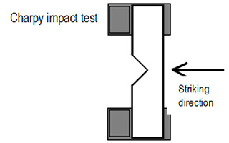

A test specimen having a V-shaped notch is fixed vertically, and the specimen is broken by striking it from the same side as that of the notch by the use of the hammer. The fracture energy is determined from the swing-up angle of the hammer and its swing-down angle. The Izod impact value (J/m, kJ/m2) is calculated by dividing the fracture energy by the width of the specimen

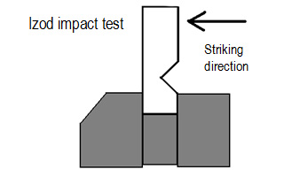

.

**Results:** Theof given Izod/charpy Impact Strength plastic sample is -------------J/m